We have collected what our model thinks volatilities are for strikes in [500, 2000) with step 10 and dates within 2 years of 2020/01/21. The surface had been initialised with market data implied vols, using an average of call and put vols as values.

This calculation can be found in tests/vol_surface_test.py, dump_vol_surface():

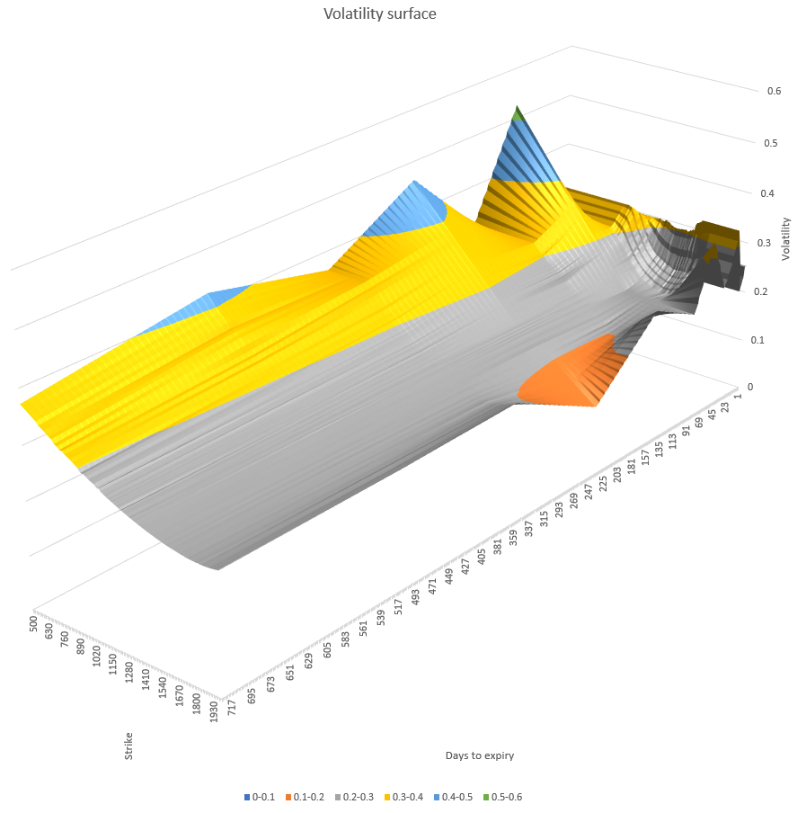

We can see volatility skew is present for most expiry dates and we can see volatility is generally growing with time. We can also observe two periods where volatility skew is more pronounced – around 2 months and 9 months.